**Types of Non- Verbal communication**

**Kinesics- It** is the interpretation of body motion communication such as facial expressions and gestures, nonverbal behavior related to movement of any part of the body or the body as a whole.

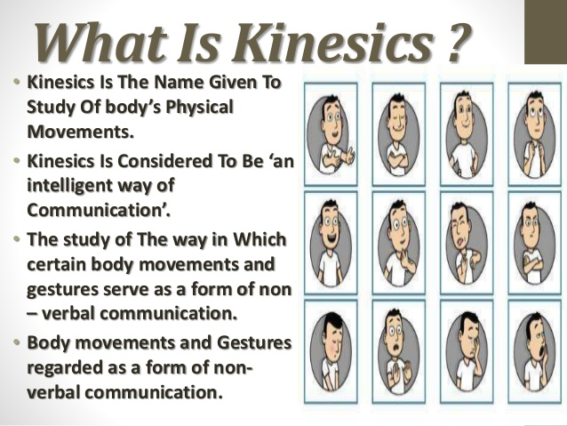

**Body Movements - Body language** is a type of a nonverbal communication in which physical behaviors, as opposed to words, are used to express or convey the information. Such behavior includes facial expressions, **body posture**, gestures, etc

**Facial expressions-** The human face is extremely expressive, able to convey countless emotions without saying a word. And unlike some forms of nonverbal communication, facial expressions are universal. The facial expressions for happiness, sadness, anger, surprise, fear, and disgust are the same across cultures.

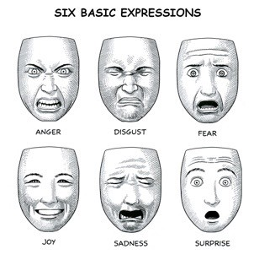

**Postures-** Consider how your perceptions of people are affected by the way they sit, walk, stand, or hold their head. The way you move and carry yourself communicates a wealth of information to the world. This type of nonverbal communication includes your posture, bearing, stance, and the subtle movements you make.

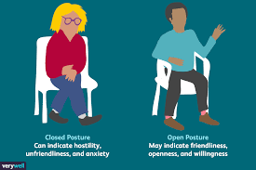

**Gestures-**  Gestures are woven into the fabric of our daily lives. You may wave, point, beckon, or use your hands when arguing or speaking animatedly, often expressing yourself with gestures without thinking. However, the meaning of some gestures can be very different across cultures. While the OK sign made with the hand, for example, conveys a positive message in English-speaking countries, it’s consider offensive in countries such as Germany, Russia, and Brazil. So, it’s important to be careful of how you use gestures to avoid misinterpretation.

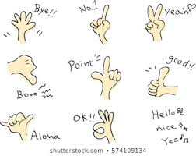

Physical Appearance- Physical or personal appearance is one of the most important that plays a vital role in communicating non verbal messages to others. Physical appearance includes clothing, ornaments, cosmetics, hairstyle etc. that a person puts together before appearing in public. The totality of physical appearance provides visual signals to a person’s interest, age, personality, style, attitude, social standing, and religious affiliation and so on.

**Proxemics or Distance**: It is an important type of non verbal communication which refers to the study of how we communicate with the space around it. Space and distance can be a powerful media of conveying message. In many organizations, space has become an indicator of the relative importance of persons. Visitors and other employees get a clear idea about the position or importance of a person by observing the location, spaciousness and decoration of his office. Distance also expresses the degree of intimacy and of cultural and individual acceptance.

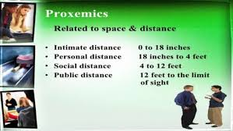

**Chronemics- It** is the study of the use of time in **nonverbal communication**. Time perceptions include punctuality, willingness to wait, and interactions. Time is an important language in case of non verbal communication that conveys specific message to others. In some countries and cultures, time is an important factor in everybody life. The use of time by a person reveals his seriousness and general practice.

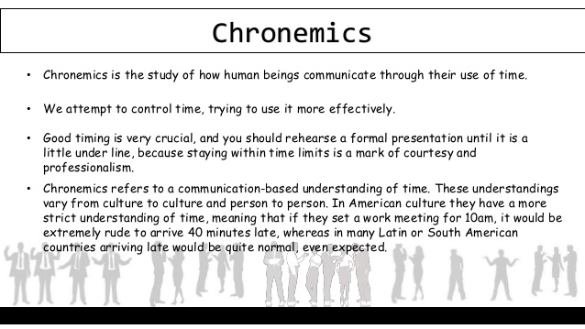

**Paralanguage -**  Paralanguage means similar to language but not exactly like language. It refers to the voice intonation which is an important communication tool. Paralanguage consists of vocal aspects of communication that relate to how something is said rather than to what is said. By its quality, volume, rate, tone, etc.,

**Haptic -** communication is exclusively designed to course the information quickly. Communicating through non-verbal haptics involves handshake, pat, slap, hug, massage, hit, kick, embrace, tickle etc. Each touch communicates a unique message like fear, disgust, love, encouragement, gratitude, sympathy, anger, pain, violence etc. Moreover, haptic communication depends on environment and interpretations such as on who, why, when and differs with setting and purpose as professional, friendship, guide, punishment, sympathy, arousal, attention, greeting, seeking, etc.

**Physical environment -** The physical environment has a big impact on nonverbal [communication](https://brainmass.com/english-language-and-literature/communication-public-speaking). Identify a referenced source that talks about the impact of a physical environment on people who work there (either generally, of in a specific case). Define each of the following terms and tell how it relates to the overall issue of nonverbal communication in the workplace interior, lighting, and physical environment.

